**Documentation for Installing Gitlab on Vagrant.**

**Step 1:** To Start the vagrant by using command Vagrant up and parallelly open the VirtualBox.

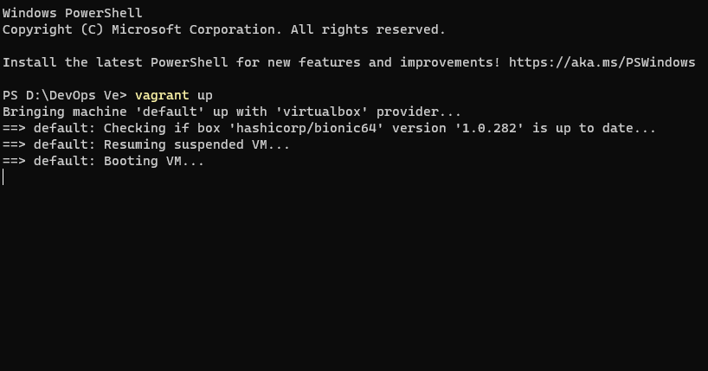

**Step 2:** Once the Machine is Start, we can see the machine in VM box make sure the system is running and click show Arrow.

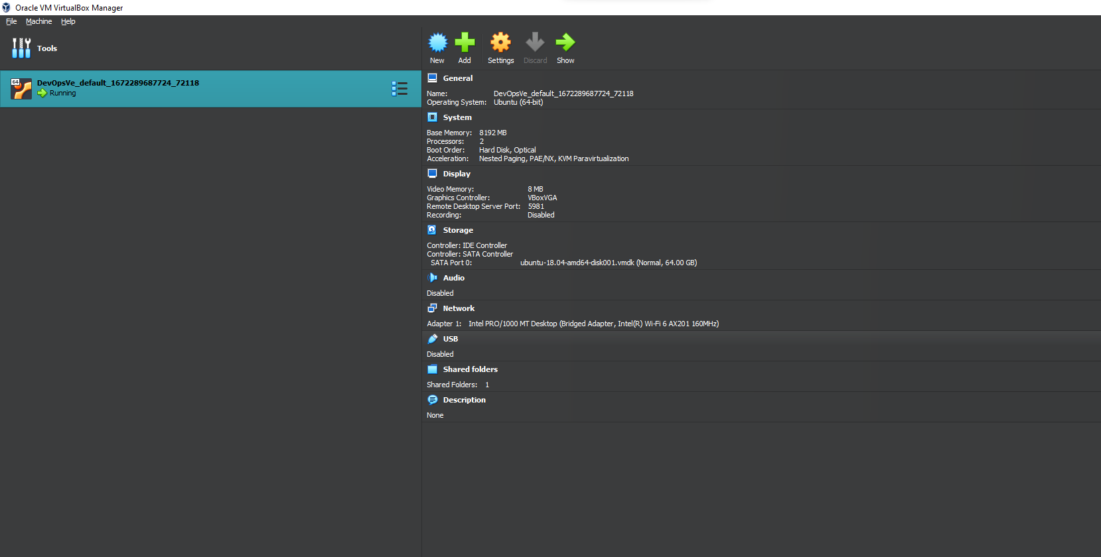

**Step 3:** The Machine ask login credentials username and password (username: vagrant, password: vagrant).

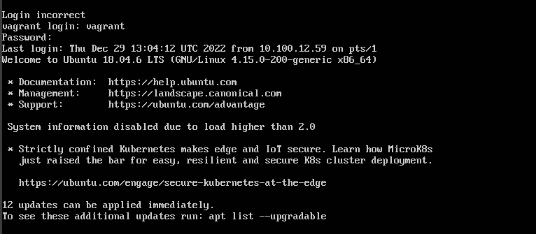

**Step 4:** If you want to connect a machine with putty make sure that network in virtual box attached to Bridged Adapter and Click ok.

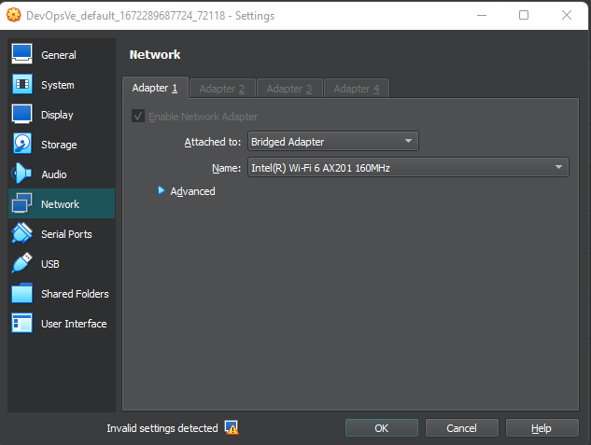

**Step 5: Check the IP using command like netstat -tulnp.**

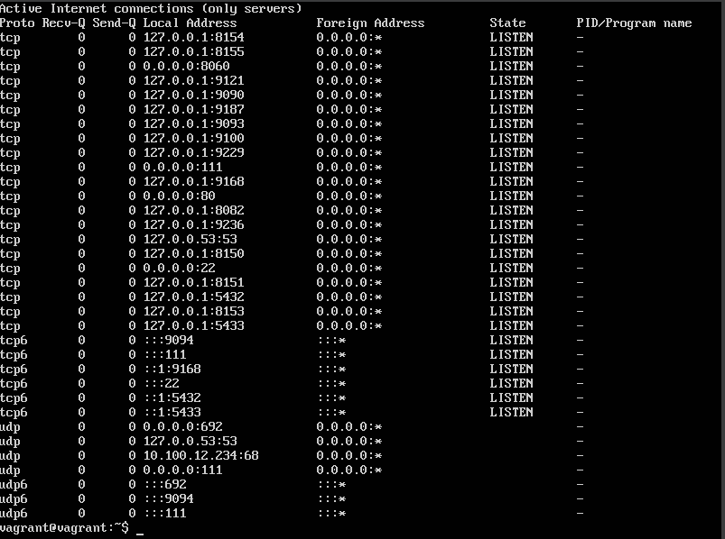

**Step 6: Open Putty and enter the Host name as we saw in step 5 and click open**

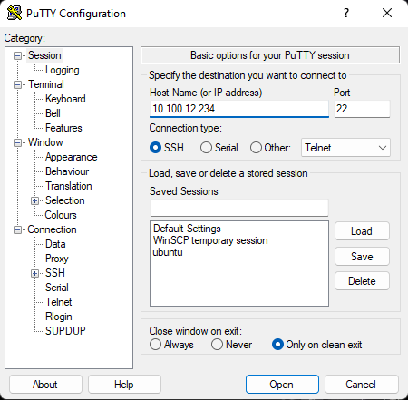

**Step 7: Enter the same Credential for login**

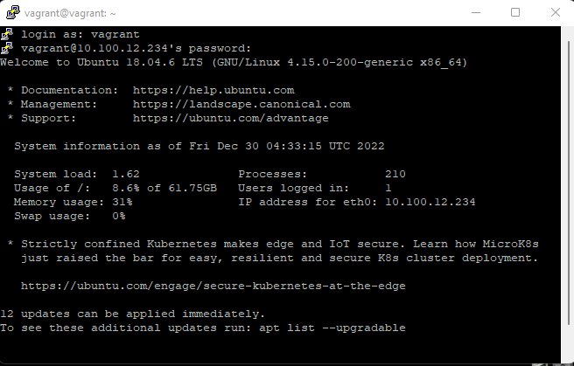

**Step 8:** For Installing GitLab Server we can follow the commands below.

**Step 9:** Install GitLab required Dependency.



**Step 10:** After the prerequisite’s installation completed, you must add GitLab repository with below commands**.**



**Step 11: you got output given below:**

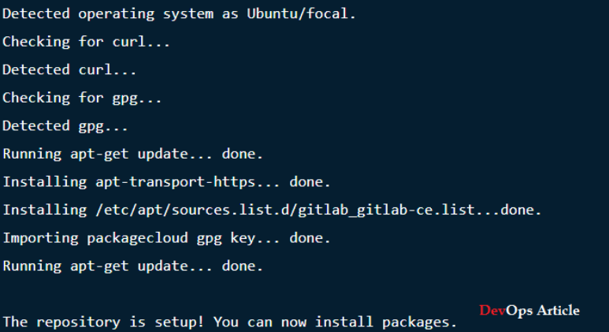

**Step 12:** Now, the repository contents are added to,

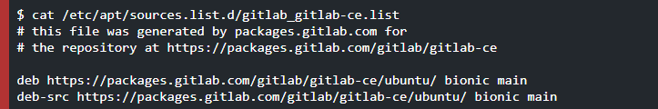

**Step 13:** Now, install GitLab using below command.



**Step 14:** You will see the below results.

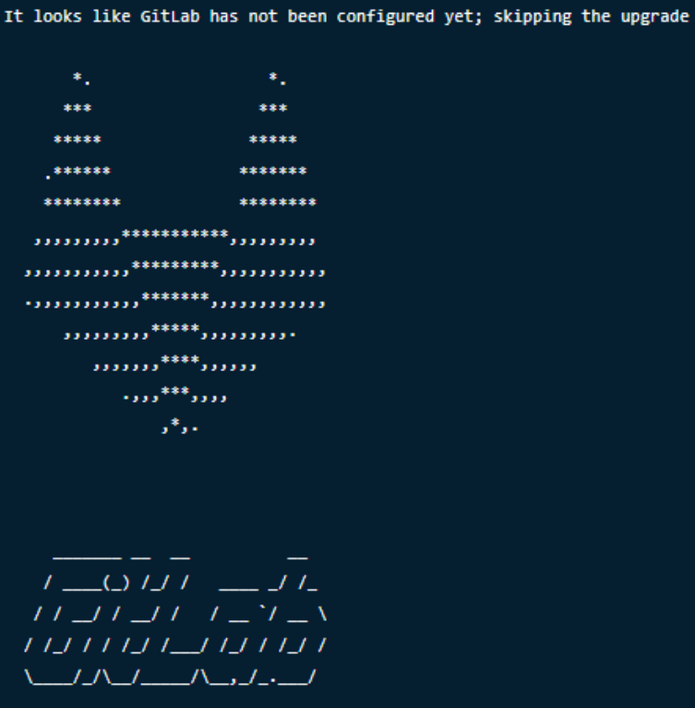

**Step 15:** Now, you can edit GitLab configuration file to set settings according to your requirements. Use below command



**Step 16:** Now, start GitLab, use below command.



**Step 17:** As soon as you hit above command, all GitLab services will  start, as you can see in below image

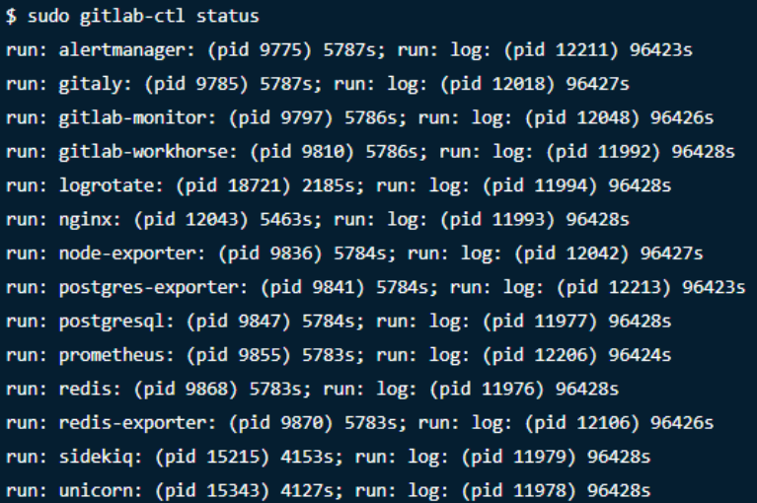

**Step 18:** Open the Browser and enter the IP and use a Username has root, For the password use the command(cat/etc/gitlab/initial_root_password) Use the initial password for login and after make to reset a password.

